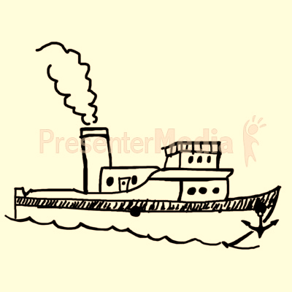

~ Address: P Sherman 42 Wallaby Way Sydney

~ Telephone: 1-800-966-1245

~Owner: Hung Dam

~Established In: 10/5/14

~Opening Times: 8:00am-12pm: Mon-Fri

9:00am-10pm: Sat & Sun

+Holidays

**ATLANTIC BLUES**

~Appetizers~**rs**

* **Garlic Butter Mussels** $2.50

Mussels are sautéed in a herd and garlic infused

butter.

* **Deep Fried Calamari w/ a Creamy Spicy Dip** $2.50

Breaded calamari fried and served w/ chili oil infused mayo dip

* **Oysters** $1.50

Oysters Steamed w/ a wedge of lemon.

* **Crab Legs** (10 pieces)$4.50

A plate of fresh and juicy Alaskan crab leg.

* **Ceviche** $4.00

A Latin-American dish with chopped shrimp, onion, red peppers, garlic, tomatoes, topped with cilantro and covered in lemon juice. (Spicy Optional)

* **Shrimp Cocktail** $3.00

Classic shrimp cocktail.

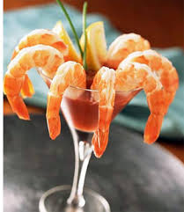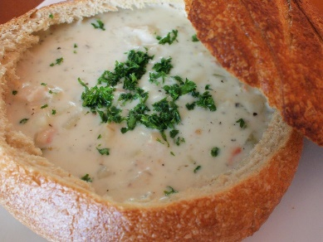

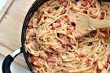

~Main Courses~

* **Lobster Pasta** $11.50

Creamy pasta w/ lobster tail, tomatoes and fresh cracked peppercorn.

* **Chowder** $8.50

Savory chowder w/ prawns, calms, crab meat, lobster meat, celery all served in a classic style sourdough bread bowl.

* **Salmon w/ Watercress** $10.00

Salmon marinated in a white wine vinegar herb mix, blanketed with a watercress sauce w/ a side of corn.

* **Fish Tacos** $13.00

Cod marinated in Mexican style sauce served w/ tortillas and an avocado salad.

* **Salmon w/ Risotto** $9.50

Seared salmon w/ a creamy mushroom and cheese risotto.

~Desserts~

* **Fruit Salad**  $2.50

Fresh sweet kiwis, watermelon, mango, strawberries,

and etc…

* **Chocolate Mousse** $3.00

Gentle and soft dark chocolate mousse w/ milk chocolate shards on a white chocolate bowl.

* **Ice Cream** $1.50

Ice cream in mint chip, chocolate, vanilla, green tea, and etc…

* **Volcano Fudge Cake** $3.00

Hot gooey fudge centre w/ a moist outer shell.

* **Crunchy Honeycomb**

**w/ Chocolate** $5.00

The highest definition of a sweet treat. A tear and share style treat w/ a sweet ganache made of dark chocolate.

~Beverages~

* **The Bloody Mary** $7.00

A classic Bloody Mary drink w/ a lobster tail, celery, lemon, and a pickle to top it off.

* **The Atlantic Blues** $7.50

Our restaurant’s specialty drink. 1 oz. gin, ⅓ oz. Blue Curacao, ⅓ Peach Liqueur, tonic water, a lemon slice to garnish served in a highball glass.

* **Soft Drinks** $1.00

Coca Cola, Sprite, Mountain Dew, Pepsi, etc…

**Coffee** $2.00

Vietnamese coffee beans, brewed for the best flavour.

(Request what you want to add to coffee).

* **Smoothies** $2.50

The freshest fruits and berries only, sugar free.

*Water is free, refills on water is also free.

~Special Offers~

* **Neptune’s Feast** $30.00

A special for 20-25 people. Comes w/ lobster, crab, chowder, bread sticks, pasta, 3 appetizers of your choice, and 2 desserts of your choice.

* **Hot Waters Weekly Special** $20.00

The seasonal, weekly fresh and best picks of seafood that include anything from imported fresh water fish to locally sourced clams and mussels.

* **Student Loan Debt Special** $10.00

Cheapest special deal for the college/university student. Comes w/ our secret (not so secret) seafood pizza and 6 cans of any soft drink of your choice.